Digital Logic Lab 2 Report

Digital Logic 2116L

2/1/2018

Featheringill 210

Suyi Diao, Bryce

1. Introduction:

The basic concepts we learned for this lab are how to use Quartz II and how to implement it on to the motherboard. Through this lab, we are trying to learn how implement logic gates on Quartz II and how to deploy it on the board.

1. Design Requirements:

We need to draw a schematic for f2 = x2x4’ + x1’x2 + x2x3

1. Diagrams

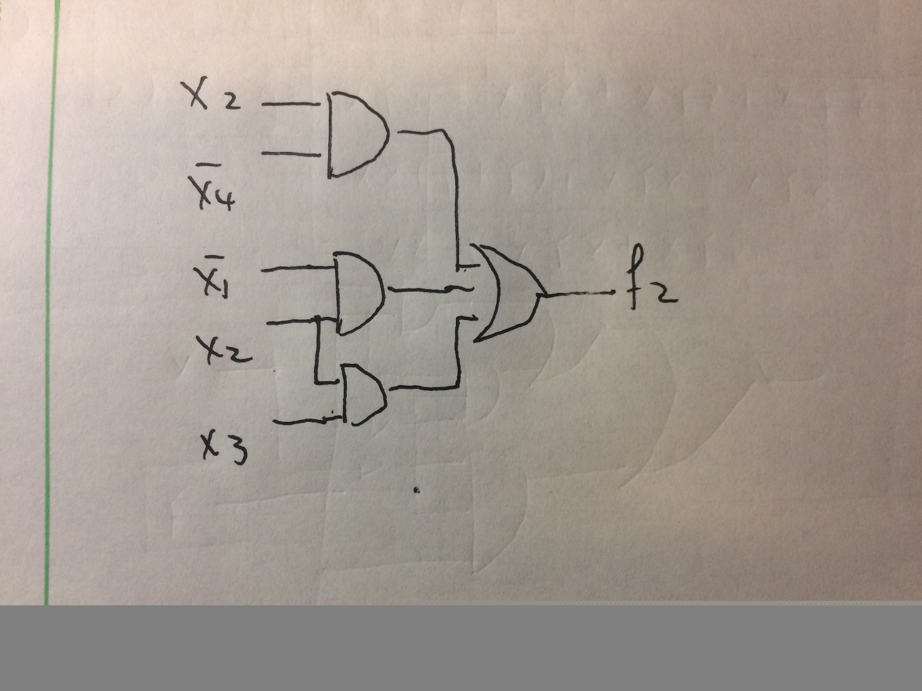

1. Results

|  |  |  |  |  |
| --- | --- | --- | --- | --- |
| X1 | X2 | X3 | X4 | F2 |
| 0 | 0 | 0 | 0 | 0 |
| 0 | 0 | 0 | 1 | 0 |
| 0 | 0 | 1 | 0 | 0 |
| 0 | 0 | 1 | 1 | 0 |
| 0 | 1 | 0 | 0 | 1 |
| 0 | 1 | 0 | 1 | 1 |
| 0 | 1 | 1 | 0 | 1 |
| 0 | 1 | 1 | 1 | 1 |
| 1 | 0 | 0 | 0 | 0 |
| 1 | 0 | 0 | 1 | 0 |
| 1 | 0 | 1 | 0 | 0 |
| 1 | 0 | 1 | 1 | 0 |
| 1 | 1 | 0 | 0 | 1 |
| 1 | 1 | 0 | 1 | 0 |
| 1 | 1 | 1 | 0 | 1 |
| 1 | 1 | 1 | 1 | 1 |

1. Discussion

Everything in the lab runs smoothly, once we know how to plug in the board, the actual lab took only 10 mins to complete.

1. Conclusion

I learned how to draw diagrams in Quartz II and how to run it on the actual board.

1. Post-Lab Questions

The gates are easier to translate from diagrams. The FPGA has more flexibility when actual implementation and not very space demanding since you can move around the gate very easily in the program.